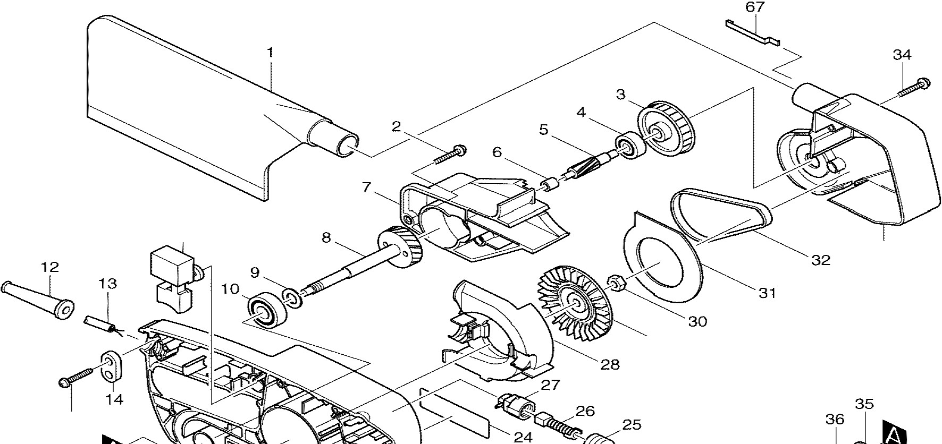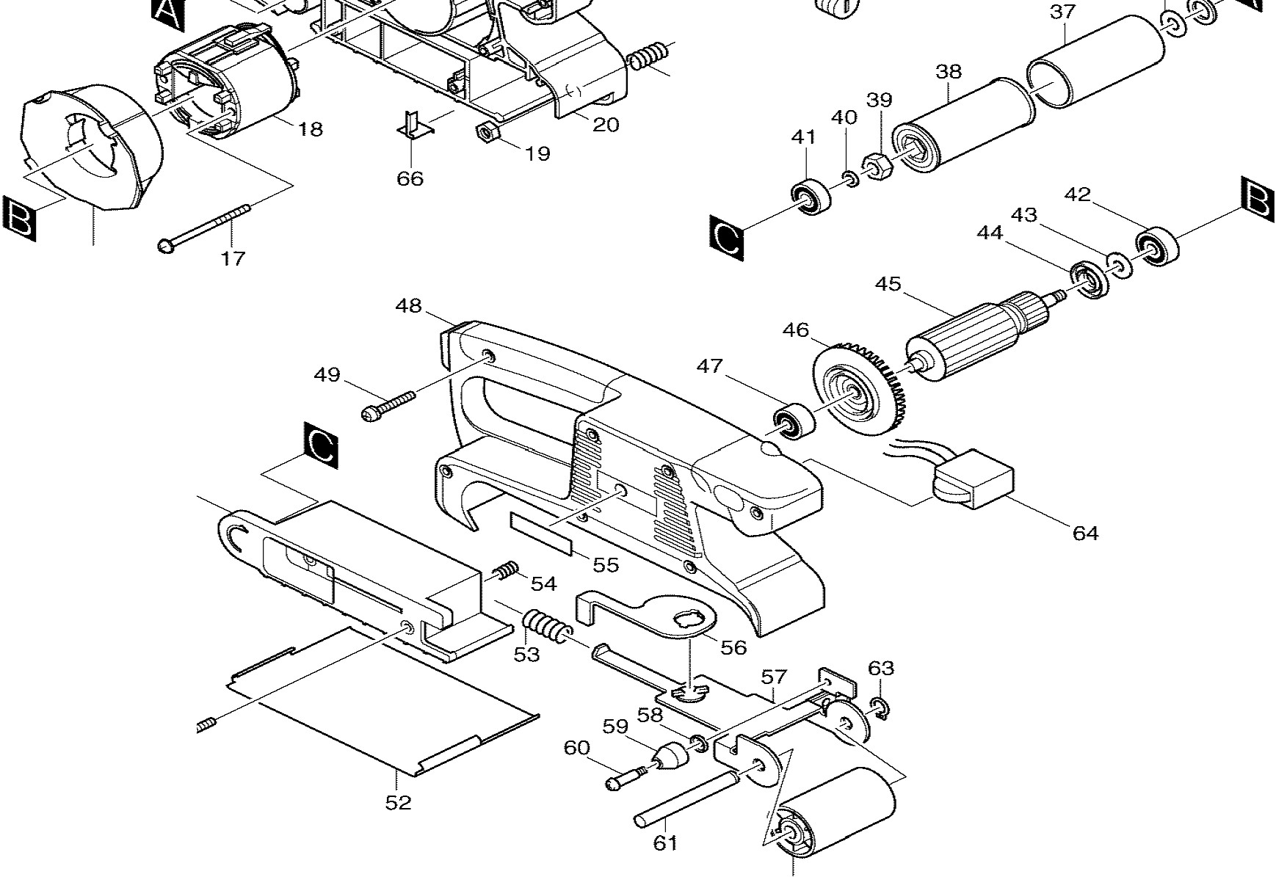
65
11
33
29
15
23
21
16
50
51

62

Fig # | Part ID | Part Name | Количество
1 | 122548-3 | DUST BAG ASS'Y, 9910 | 1
2 | 265999-8 | TAPPING SCREW M4X25, HM1800 | 4
3 | 222144-8 | PULLEY 8.5-45.1,9910 | 1
4 | 210005-4 | BALL BEARING 608DDW, 9031 | 1
5 | 226494-3 | HELICAL GEAR 6, 9910 | 1
6 | 212009-2 | NEEDLE BEARING 509, 9910 | 1
7 | 416420-2 | BRACKET, 9910 | 1
8 | 153252-3 | HELICAL GEAR 31 CPL., 9910 | 1
9 | 253758-2 | F. WASHER 10, 9901 | 1
10 | 211061-7 | B. BEARING 6000LLB, 6222DWE | 1
11 | 650232-5 | SWITCH, 9911 | 1
11 | 651285-7 | SWITCH, 9910 | 1
12 | 682502-4 | CORD GUARD 8-85, HP1621F | 1
13 | 664891-9 | CORD | 1
14 | 687063-9 | STRAIN RELIEF, 4323K | 1
15 | 265995-6 | TAPPING SCREW 4X18, 4323K | 2
16 | 416418-9 | BAFFLE PLATE, 9910 | 1
17 | 266052-3 | TAPPING SCREW FLANGE PT4X60,HR2410 | 2
18 | 633391-0 | FIELD 115V, 9910 | 1
19 | 931202-6 | HEX NUT M5, HR2410 | 1
20 | 150958-4 | HOUSING L, CPL.,9911 | 1
21 | 233219-8 | COMPRESSION SPRING 6, 9910 | 1
23 | 911252-7 | P.H. SCREW M5X30, 2711 | 1
24 | 859230-8 | NAME ?LATE, 9911 | 1
25 | 643550-8 | BRUSH CAP , 9031 | 2
26 | 191938-1 | CARBON BRUSH 408 SET, 3901 | 1
27 | 643922-7 | BRUSH HOLDER, JN1601 | 2
28 | 416416-3 | SCROLL PLATE, 9910 | 1
29 | 241660-1 | FAN 68, 9910 | 1
30 | 252153-3 | HEX NUT M6-10, 9910 | 1
31 | 344584-1 | PLATE, 9910 | 1
32 | 225079-2 | SYNCHRO BELT 6-300, 9910 | 1
33 | 183021-8 | BELT COVER SET, 9910 | 1
33 | 416415-5 | BELT COVER, 9910 | 1
34 | 265999-8 | TAPPING SCREW M4X25, HM1800 | 4
35 | 267177-6 | FLAT WASHER 12, 9910 | 1
36 | 253865-1 | F. WASHER 8, HR5000 | 1
37 | 422032-1 | RUBBER SLEEVE 29, 9910 | 1
38 | 316971-4 | DRIVING ROLLER, 9910 | 1
39 | 252154-1 | HEX NUT M8-13, 9910 | 1
40 | 253077-6 | F. WASHER 6, 2040 | 1
41 | 210022-4 | BALL BEARING 626DDW, 9910 | 1
42 | 210023-2 | BALL BEARING 627DDW, 9910 | 1
43 | 253823-7 | F. WASHER 7, LS1011 | 1
44 | 681648-3 | INSULATION WASHER, 9910 | 1
44 | 681658-0 | INSULATION WASHER | 1
45 | 517241-6 | ARMATURE ASS'Y 115V, 9910 | 1
46 | 240008-4 | FAN 60, 9910 | 1
47 | 211021-9 | BALL BEARING 607LLB, LS1013 | 1
48 | 182982-9 | HOUSING R, 9911 | 1
49 | 265999-8 | TAPPING SCREW M4X25, HM1800 | 7
50 | 416419-7 | SHOE, 9910 | 1
51 | 265999-8 | TAPPING SCREW M4X25, HM1800 | 2
52 | 344586-7 | STEEL PLATE, 9910 | 1
52 | 344586-7 | STEEL PLATE, 9910 | 1
52 | 345503-0 | STEEL PLATE, 9910 | 1
53 | 233221-1 | COMP. SPRING 12, 9910 | 1
54 | 231038-6 | COMP. SPRING 5.5, LS1011 | 1
55 | 819063-3 | MAKITA LABEL, 6992DWDE | 1
56 | 344585-9 | LEVER, 9910 | 1

57 | 150837-6 | TENSION ROLLER ARM CPL., 9910 | 1
58 | 267731-6 | Тарельчатая шайба , 9910 | 1
59 | 416417-1 | ROLLER, 9910 | 1
60 | 265059-6 | SHOULDER SCREW M4, 9910 | 1
61 | 323776-5 | Вал натяжного ролика, 9910 | 1
62 | 152585-3 | Передний натяжной ролик со втулками, 9910 | 1
63 | 961004-6 | Стопорное кольцо S-8, DA391D | 1
64 | 631182-3 | Контроллер регулировки оборотов, 4304 | 1
64 | 631675-0 | Контроллер регулировки оборотов, 4304 | 1
64 | 631678-4 | Контроллер регулировки оборотов
66 | 344703-9 | EARTH SUPPORTER, 9910 | 1
67 | 344701-3 | EARTH PLATE, 9910 | 1
1,001 | 794551-0 | ABRASIVE BELT 76X457 WA80, 9911 | 1

